TWAHIRAH KIDS JUNIOR SCHOOL-BUSULA
P.2 END OF TERM I INTERNAL EXAMINATIONS – 2024

Literacy IB

Name: ________________________________________________

1(a) Who heads a schools?
___________________________________________________(b) Give one symbol of a school?
___________________________________________________
(c) What is the use of a nurse in a school?
___________________________________________________
(d) How is money useful in a school? ___________________________________________________
2(a) Give one insect that spreads diseases.
___________________________________________________
(b) Name one disease we prevent by immunisation.
___________________________________________________
(c) Mention one sign of measles.
___________________________________________________

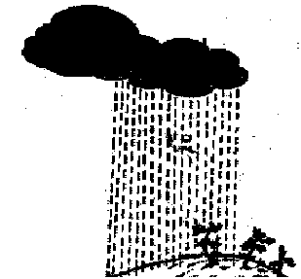3. The diagram shows one of the weather conditions.

(a) What type of weather is shown in the diagram?
__________________________________________________
(b) Name one item we use to protect ourselves from the type of weather.
_________________________________________________
(c) Give one way the above type of weather is useful to man.
_________________________________________________
4(a) Mention one duty of a mother in a family.
__________________________________________________
(b) In which type of family do we find uncles?
_________________________________________________
(c) Give one basic need of a family.
________________________________________________
(d) State one way the head of a family gets money.
________________________________________________
5(a)Give one use of trees to people.
________________________________________________
(b) Mention one thing used to clean the school compound.
_________________________________________________
(c) Name one source of water.
_________________________________________________
(d) Give one use of water in a home.
_________________________________________________
6(a) Name one place where we get food.
_________________________________________________
(b) Mention one tool farmers use to grow food.
__________________________________________________
(c) Under what type of food are beans?
_________________________________________________
7(a)Give the importance of a doctor to a community.
___________________________________________________
(b) Where do drivers go to buy petrol for their cars?
___________________________________________________
(c) Mention the use of a bank to people in a community.
___________________________________________________
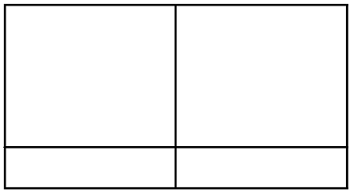8. Draw and name two body parts found on the head.

9(a)Mention one item used to keep the tooth clean.
___________________________________________________
(b) Name one body part we keep clean using a razorblade.
___________________________________________________
(c) Give one way of keeping our hair clean.
___________________________________________________
10(a)Name the part of a house used for letting air in.
___________________________________________________
(b) Give one material used to build the roof of a house.
___________________________________________________

(c) Which part of a house is used for keeping cars?
___________________________________________________
11. Match correctly.
(a) train air transport
(b) boat railway transport
(c) helicopter water transport
12(a)Name the domestic animal that provides security to our homes.
__________________________________________________
(b) How is a cow useful in a home?
__________________________________________________
(c) Mention one thing people get from hens.
__________________________________________________
13(a)Name one item found in a first aid box.
__________________________________________________
(b) Give one danger of leaving broken bottles in the compound.
___________________________________________________
(c) Name the road sign drawn below.


___________________________________________________
14(a)Name one item made from clay.
___________________________________________________
(b) Mention one material used to make shoes.
___________________________________________________
15(a)Give on use of a fence to a school.
___________________________________________________
(b) Mention one group of people who keep peace and security in our school.
__________________________________________________

RELIGIOUS EDUCATION
ISLAM:
16 Write two names given to girls in Islam.
(a) ______________________ (b) ____________________
17. Give two gifts Allah gave to people.
(a) ______________________ (b) ____________________
18. On which day do Moslems go for Juma Prayers?
________________________________________________

